HIGH LEVEL CONFERENCE ON CLIMATE CHANGE AND OCEANS PRESERVATION

19 February 2019 - Egmont Palace

Programme

08:00 – 09:00 Registration

09.00 – 10.00 Opening ceremony

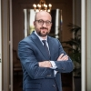 Charles Michel, Prime Minister (Belgium)

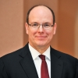 H.S.H. Prince Albert II of Monaco

Marie Christine Marghem, Minister of Energy, Environment and Sustainable Development (Belgium)

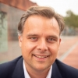 Philippe De Backer, Minister of the North Sea (Belgium)

10.00 - 11.15 Panel 1 : Climate change and impact on Ocean biodiversity

Moderator :

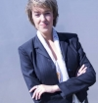 Fanny Douvere, UNESCO, World Heritage Marine Programme Coordinator

Keynote speaker :

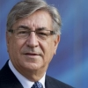 Karmenu Vella, EU Commissioner for Environment, Maritime Affairs and Fisheries

Speakers :

Brune Poirson, State Secretary to the Minister of State Ecological and Inclusive Transition (France)

Isabel Torres de Noronha, Future Ocean Alliance, President

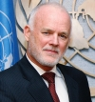 Peter Thomson, United Nations Special Envoy for Oceans

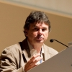 Denis Allemand, The Monaco Scientific Centre, Scientific Director

11.15 - 11.45 Coffee Break

11.45 - 13.00 Panel 2 : How to conciliate Ocean energy with Marine conservation

Moderator :

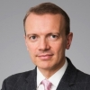 Giles Dickson, Wind Europe CEO

Keynote speaker :

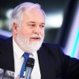 Miguel Arias Cañete, EU Commissioner for Climate Action & Energy

Speakers :

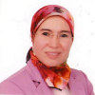 Nezha El Ouafi, Minister of Sustainable Development (Morocco)

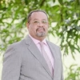 Guy-Bertrand Mapangou, Minister of State, Minister of Forests and Environment in charge of the Climate Plan (Gabon)

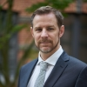 Rémi Gruet, Ocean Energy Europe CEO

Nicolas Entrup, Ocean Care, Ocean Policy Consultant

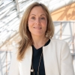 Emma Navarro, European Investment Bank's Vice-President

13.00 - 14.00 Lunch

14.00 - 14.30 The Maritime Industry Decarbonisation Council
Presentation by the RBSA
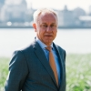
Wilfried Lemmens, Royal Belgian Shipowners' Association, Managing Director

14.30 - 15.45 Panel 3 : Reducing greenhouse gas emissions from ships
Moderator :

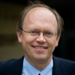 Jean-Pascal van Ypersele, Former IPCC Vice-Chair, Prof. KU Leuven

Keynote speaker :

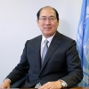 Kitack Lim, International Maritime Organization, Secretary-General

Speakers :

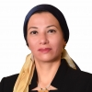 Yasmine Fouad, Minister of Environment (Egypt)

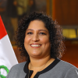
Fabiola Martha Muñoz Dodero, Minister of Environment (Peru)

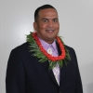 David Paul, Minister of Environment (Marshall Islands)

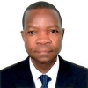 Joseph Seka Seka, Minister of Environment and Sustainable Development (Ivory Coast)

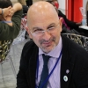 Rémi Parmentier, Coordinator, Secretariat of the Because the Ocean initiative

15.45 – 16.15 Closing session

Marie Christine Marghem, Minister of Energy, Environment and Sustainable Development (Belgium)

Philippe De Backer, Minister of the North Sea (Belgium)

Raul Fernandez Daza, Ambassador, Presidency of the COP25 (Chile)

Representatives of Belgian Youth Council

16.15 – 18.00 Reception and Signature of "the Brussels Declaration"

Official Conference Languages: English, French

