Integration income
in Belgium

Explanatory guide and figures (18/01/2024)

Integration income is a minimum income for people who do not have sufficient resources. This is just one of the forms that the right to social integration can take in Belgium.

What conditions must be met to receive integration income? How much is this income? Who should I request it from? Does integration income need to be repaid? How many people in Belgium benefit from it each year?
You'll find the answers to all your questions in this file.

What conditions must be met to receive integration income in Belgium?
To receive integration income, you must meet all of the following conditions:
- Have your habitual residence in Belgium.
- Be an adult (at least 18).
Minors are also entitled to integration income if they are married, have a dependent child or are pregnant.
- Be Belgian or (a family member of) a citizen of the European Union, a recognised political refugee, a beneficiary of subsidiary protection, stateless or a foreign national entered in the population register.
- Have insufficient resources. That includes all kinds of income within the household.
- Be willing to work unless health or equity reasons prevent it. Examples of equity reasons: the person is still studying, or the PCSW wishes to resolve other issues first.
- Exercise your rights to other benefits. The PCSW checks whether the applicant is entitled to unemployment benefits, disability benefits, etc.
- For those under 25: sign a contract with the PCSW. This contract defines the agreements between the applicant and the PCSW, for example, on looking for a job, following a training course or studying. People aged 25 or over must also sign a contract with the PCSW if they have not received an integration income in the last three months.

In addition to these conditions, other criteria may also be imposed.

Who should you request integration income from?
Anyone wishing to apply for integration income must contact the PCSW of the municipality or town in which they live or have their habitual residence. If you are still studying, you must go to the municipality where you are entered in the population register.

How does the process work?
Once the application has been submitted, the PCSW provides the applicant with proof that an application has been made.
The PCSW then conducts a social investigation, checking civil status, income, household composition, etc. It gathers all the information needed to speed up the processing of an application.
Based on the social investigation, the PCSW will decide, no later than thirty days after the application, whether or not the person is entitled to integration income. The applicant has the right to be heard by the PCSW administration before the decision is taken.
If the person does not agree with the decision taken by the PCSW (integration income is refused or the amount granted is lower than expected), they can submit an appeal against the decision. To do so, they have three months from receipt of the decision. The letter informing you of the PCSW's decision explains how and where to submit an appeal. Appeals are always free of charge.

How much is integration income?
The monthly amount depends on the applicant's family situation.
There are 3 possible cases:
- 842.12 euros if the applicant is cohabiting with another adult. Whether or not they have a relationship with this person is irrelevant. Cohabiting with someone means living under the same roof and sharing the same household.
- 1,263.17 euros if the applicant is living alone.
- 1,707.11 euros if the applicant is cohabiting with at least one dependent minor child.
The rules governing the amount of integration income are the same for all PCSWs in Belgium.
(Amounts applicable from 01/11/2023)

Does integration income need to be repaid?
In most cases, integration income does not have to be repaid unless:
- The person then receives income for the period during which they received integration income. For example: they receive integration income for the month of September, and in November they receive unemployment benefits retroactive to September. They will then have to repay the integration income from September because they received another income for that month.

- If they have or receive income and do not inform the PCSW, or if they make false declarations (for example, they do not state that they are cohabiting), in principle they will have to repay integration income.
The PCSW cannot therefore claim integration income back if the person's financial situation subsequently improves. For example: a person receives integration income in September and starts work in October. They will not have to repay integration income for September.

A few figures

Number of RIS (social integration income) beneficiaries - 2023
This is the situation in November 2023, i.e. the number of people having benefited from RIS for at least one month over the period January-November 2023.
In Belgium:
Year | Beneficiaries | Residents
2022 | 214,337 | 11,584,008
2023 | 209,508 | 11,697,557
In Flanders:
Year | Beneficiaries | Residents
2022 | 59,794 | 6,698,876
2023 | 58,977 | 6,774,807
In Wallonia:
Year | Beneficiaries | Residents
2022 | 97,767 | 3,662,495
2023 | 95,018 | 3,681,575
In Brussels:
Year | Beneficiaries | Residents
2022 | 58,503 | 1,222,637
2023 | 56,938 | 1,241,175

Evolution in number of RIS beneficiaries over the past 6 years

Age of applicants
 | 2017 | 2018 | 2019 | 2020 | 2021 | 2022
Under 25 | 67,499 | 69,995 | 70,884 | 73,650 | 76,216 | 75,711
25-34 years | 50,525 | 51,074 | 51,175 | 52,070 | 51,644 | 51,062
35-49 years | 52,372 | 52,798 | 53,044 | 53,710 | 53,776 | 53,794
50-64 years | 27,951 | 28,531 | 29,108 | 29,448 | 29,911 | 30,014
65 and over | 3,480 | 3,742 | 4,062 | 3,688 | 3,661 | 3,756

Family situation of applicants
 | 2017 | 2018 | 2019 | 2020 | 2021 | 2022
Cohabiting | 72,115 | 74,259 | 75,272 | 77,405 | 78,495 | 77,824
Living alone | 85,653 | 86,913 | 86,818 | 89,190 | 91,982 | 90,916
With dependent family | 62,725 | 63,724 | 64,706 | 64,171 | 63,123 | 63,395

Gender of applicants
 | 2017 | 2018 | 2019 | 2020 | 2021 | 2022
Female | 104,099 | 106,243 | 108,560 | 111,300 | 112,826 | 113,395
Male | 97,728 | 99,897 | 99,713 | 101,266 | 102,382 | 100,942

Nationality of applicants
 | 2017 | 2018 | 2019 | 2020 | 2021 | 2022
Belgian | 138,434 | 139,876 | 142,864 | 146,640 | 148,493 | 147,484
Outside of the European Union | 48,729 | 51,195 | 50,111 | 48,934 | 49,327 | 49,398
European national | 15,562 | 15,919 | 16,231 | 17,941 | 18,479 | 18,714

Non-take-up of integration income
Non-take-up concerns people who do not obtain the public benefits and services to which they are entitled.
A number of factors may explain why people do not take up integration income (the application procedure not being user-friendly, lack of awareness of the benefit, fear of stigmatisation, etc.).
Efforts have been made in terms of providing information (brochure for users, etc.) to improve awareness of rights.
Rate of non-take-up in Belgium:
- 62% for integration income (RI) in 2005
- 43% to 46% depending on the RI model in 2019

Change in monthly RIS amount over the last 6 years (in euros)
Effective date | Category 1 | Category 2 | Category 3
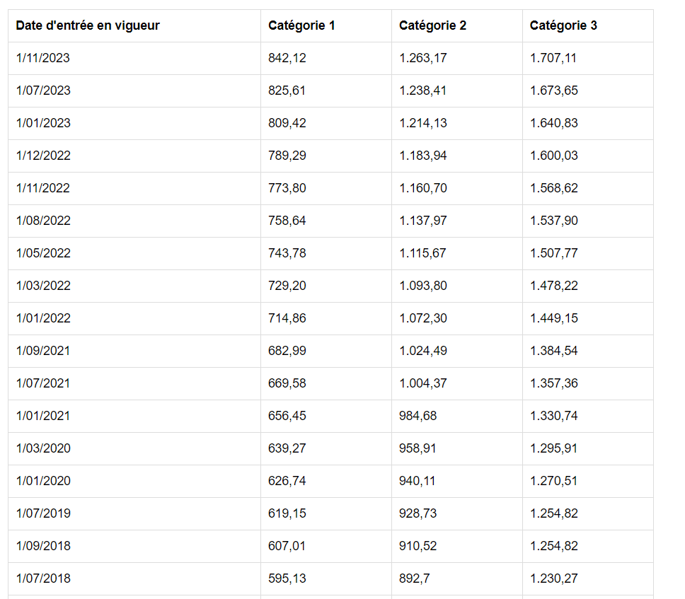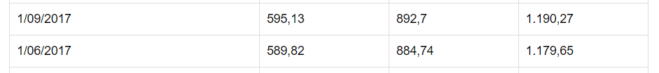
Cat 1 = cohabiting person
Cat 2 = person living alone
Cat 3 = person cohabiting with at least one dependent child
More Belgian statistics at https://stat.mi-is.be/fr

Press questions:
- By email: MI.Press@mi-is.be
- By phone: 02 508 86 22

Source: PPS Social Integration
Bouckaert, N., Schokkaert E. (2011). Une première évaluation du non-recours au revenu d’intégration. Revue belge de sécurité sociale, 53(4), pp. 609-634.
Van Gestel, R., Goedemé, T., Janssens, J., Lefevere, E., & Lemkens, R. (2022). Improving Take-Up by Reaching Out to Potential Beneficiaries. Insights from a Large-Scale Field Experiment in Belgium. Journal of Social Policy, 1-21.

