The Child Guarantee
in Belgium

Information guide (xx/05/2024)

One in five children live in poverty in Belgium. One in four in Europe.

In 2022, almost 20 million children under the age of 18 were at risk of poverty or social exclusion in the European Union.

To combat these rates of child poverty and social exclusion, on 14 June 2021, the Council of the European Union adopted the recommendation on the European Child Guarantee. It aims to reduce the number of people at risk of poverty or social exclusion by at least 15 million, including 5 million children, by 2030.

As Belgium assumes the presidency of the Council of the EU, this challenge remains high on the European agenda.

***
When is a child considered to be at risk of poverty or social exclusion?

What role does the PPS Social Integration play in the national action plan for the European Child Guarantee?

What is the current state of national initiatives?

What are the figures for child poverty in Belgium?

You will find the answers to all your questions in this file.

What do we mean by "risk of poverty or social exclusion"?
At risk of poverty or social exclusion, abbreviated as AROPE, corresponds to the sum of persons:
- Whose disposable income is below the poverty line, which stands at €1,450 for a single person and €3,045 for a household of two adults and two children.
- Who are severely materially and socially deprived (SMSD). They are then unable to pay for certain goods, services or activities considered necessary or desirable by most people in order to achieve an acceptable standard of living.
- Who live in a household with a low work intensity (LWI). This means that household members of working age worked a working time less than 20% of their total work-time potential during the previous 12 months.

People are included only once even if they are in more than one of the situations mentioned above.

AROPE is the main indicator for monitoring the EU 2030 target on poverty and social exclusion.

What's the challenge for Belgium?
To implement the Recommendation establishing the European Child Guarantee, EU Member States have appointed their coordinators and prepared national action plans covering the period up to 2030.

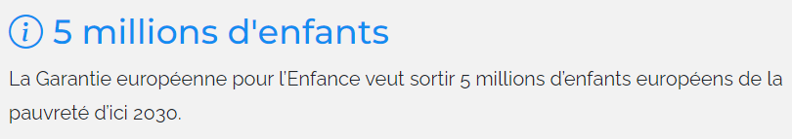

In May 2022, Belgium submitted its "European Child Guarantee" national action plan to the European Commission.
Belgium's institutional complexity poses a particular challenge, as the Child Guarantee covers several policy areas at different levels of authority. The Belgian action plan is therefore the result of coordinated cooperation between all the political levels responsible for children's rights and the fight against poverty, and civil society organisations familiar with the issue.

A comprehensive, coordinated and collaborative approach
On the whole, the federal and federated entities have opted for measures aimed at all children in poverty, as they have many needs that are generally all the same. In addition to general measures, the federated entities have more specific targeted measures aimed at certain vulnerable groups, such as children with disabilities, Roma children and children of migrants and new arrivals.

Combating child poverty requires a coordinated approach. Measures to break the vicious circle of poverty are therefore included in the various policies and action plans of the political bodies concerned.
In the Belgian federal context, each competent authority develops concrete actions according to its competences. As most of the competences of the European Child Guarantee fall under the responsibility of the Communities and Regions, most of the actions take place at these levels of power. The federal government plays a coordinating role in developing and monitoring the action plan.

The Public Planning Service for Social Integration coordinates the preparation, implementation and monitoring of the Child Guarantee. To this end, the PPS has developed a monitoring process, in collaboration with the federated entities' single points of contact (SPOCs) and stakeholders (organised into working groups).

In the Regions and Communities, a single contact person has therefore been appointed for Flanders, the Walloon Region, the Wallonia-Brussels Federation, the Brussels-Capital Region, the French Community Commission, the Flemish Community Commission, the Common Community Commission and the German-speaking Community. They represent the regional and community administrations in the administrative working group responsible for drawing up the action plan.
At Belgian level: the national action plan for the European Child Guarantee is monitored every two years.

At European level: progress in implementing the national action plan will be communicated to the Council of the European Union in a report after five years at the latest.
In the meantime, Member States can send their mid-term reports to the European Commission. Some of these are already available on the Commission's website, in particular those for Belgium.

Beyond the Belgian political and institutional framework, considerable attention is paid to consulting civil society. Several times a year, the PPS Social Integration organises specific consultation forums on the fight against poverty – including child poverty.

What are the Belgian objectives?
Belgium wants to contribute to the European ambition of lifting five million children out of the risk of poverty by 2030, and its target contribution to this European objective is to have at least 93,000 fewer children living in poverty by 2030.

The aim is to ensure that children in need have effective access to a range of essential services, as set out in the recommendation on the Child Guarantee:
- Free early childhood education and care facilities
- Free schooling (including extracurricular activities and at least one healthy meal every school day)
- Free health care
- A healthy diet
- Adequate housing
→ 93,000 children
Belgium aims to lift 93,000 children out of poverty by 2030.

Where are we now?
The federal government and federated entities have taken various measures to meet the requirements of the European Child Guarantee, focusing on the prevention of child poverty, access to essential services and education for children and young people.

A report, published in May 2022, draws up a non-exhaustive inventory of actions taken or to be taken at federal, community and regional level.

- The list can be viewed at the following link: https://www.mi-is.be/en/european-child-guarantee-belgian-national-action-plan

Here is a summary of the main initiatives:

- Outreach and raising awareness:
Awareness-raising initiatives have been launched to inform children and their parents about their social rights.

- Prevention of child poverty:
Communities and Regions focus on preventing child poverty by raising awareness among all those in contact with children and their parents, including public services, associations, crèches and schools. Efforts are made to detect and prevent poverty as early as possible.

- Financial support:
At federal level, a budget of around €2.2 million was released between 2021 and 2023 to enable the Public Centres for Social Welfare (PCSWs) to help the most vulnerable families. In collaboration with the National Lottery, a call for projects to combat child poverty was launched in 2023. This enabled 62 projects to be subsidised in Belgium, amounting to almost €1,200,000. A new call for projects on the same theme was launched in early 2024, with a budget of €1,800,000.

- Enhancing local services:
The Communities and Regions strengthen local cooperation between local players to provide appropriate additional support and services for children in vulnerable situations. Initiatives have been launched to strengthen the supply of directly accessible assistance and improve access to healthcare and social services.

- Awareness and education:
Awareness and education programmes have been set up to inform children and young people about their rights, as well as topics such as mental health, online safety and drug prevention. Initiatives have also been launched to support education, as well as sporting and cultural activities for disadvantaged children.

- Involvement of stakeholders:
The PPS Social Integration organised four seminars in 2023, each focusing on one of the themes of the European Child Guarantee. The federated entities have mandated delegations made up of experts from administrations, civil society organisations, universities, etc.
These meetings enabled us to start monitoring the Plan's implementation in a coordinated manner, and to draw up a review of child poverty in Belgium, and more specifically of the challenges that will need to be met in the future.

What are the challenges ahead?
One of the main lessons learned from these seminars is the importance of coordination and communication to successfully implement the Child Guarantee in Belgium.

In the future, particular attention will be paid to gathering administrative data which, to date, is insufficient and too dispersed between the various levels of authority. The aim will be to bring together all existing information to provide a global view of all actions and their impact on the Belgian territory as a whole.
The contact persons from each federated entity have been asked to facilitate the collection of this data and an exercise to map the information has already been launched. This mapping will enable better monitoring of the target groups and the impact of the various actions implemented.

In addition, Belgium wishes to capitalise on the momentum generated by the seminars, and maintain a regular forum for exchange between the many experts, political representatives, representatives of civil organisations and academics who have taken part in these meetings:
- To enable close dialogue with a view to formulating common, achievable recommendations
- To enable the implementation of further initiatives within each level of authority.

Work on the recommendations already began at the closing seminar at the end of 2023. A number of challenges and possible solutions have been highlighted, which could form a starting point for the continuation of these working groups in 2024, with the aim of formulating more comprehensive and concrete recommendations.

A few figures

The situation in Belgium

In Belgium, 2,150,000 people (18.6% of the population) are at risk of poverty or social exclusion (AROPE), according to the EU-SILC 2023 survey.
Concerning children (under 18):
- 19% are at risk of poverty or social exclusion
- 13.2% are at risk of poverty
- 8.8% belong to households with very low work intensity
- 4.6% are severely materially or socially deprived
These percentages have been falling since 2018, except for the rate of children who are severely materially or socially deprived, which rose slightly between 2022 and 2023 (+0.3%).

Graphical view – development from 2015 to 2023

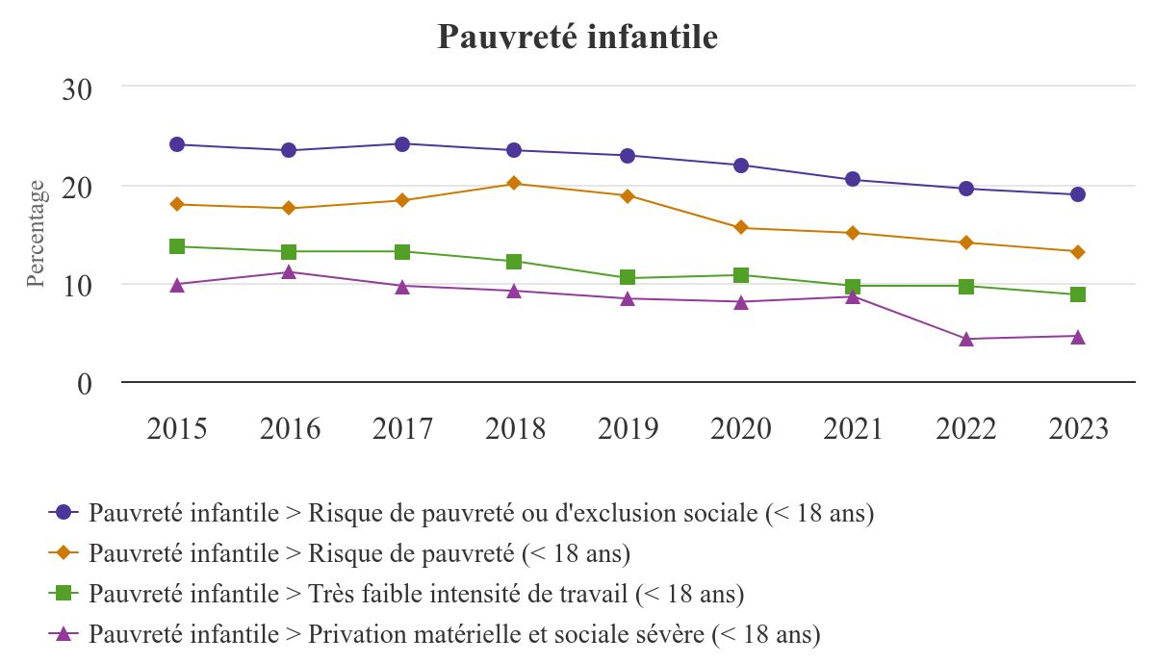

Table view – development from 2015 to 2023

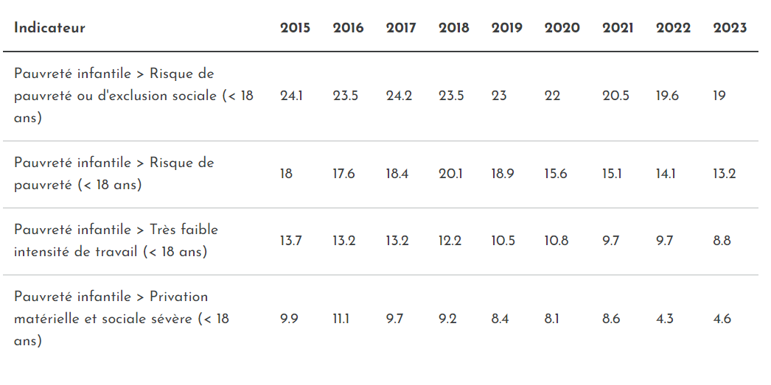

Intergenerational poverty
Statbel, the Belgian statistical office, studied the intergenerational transmission of poverty within the EU-SILC 2019 survey. The survey respondents aged 25 to 59 were asked what their living conditions were when they were around 14.

Intergenerational transmission

The survey sheds light on the effect of deprivations during teenage years on the financial situation in adulthood.

Among the people who were living in a household facing great financial difficulties at the age of 14, 30.4% lived under the monetary poverty threshold in 2019. On the contrary, the current poverty rate only amounts to 7.7% for those who were living in a household in a very good financial health.

Monetary poverty by financial situation of the household
when respondent was around 14 years old

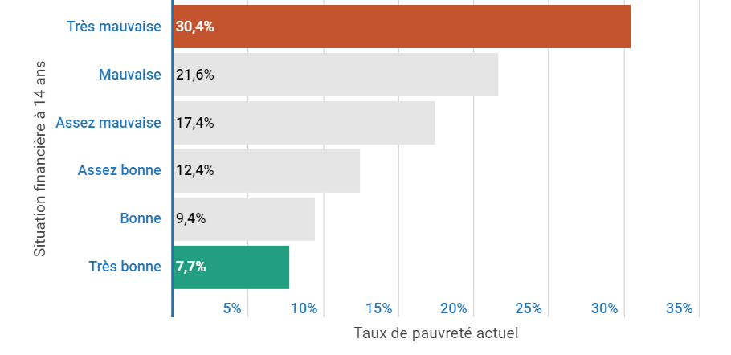

Another example: 35.5% of the respondents who declared not having had basic school supplies for financial reasons at the age of 14 are currently at risk of poverty compared to 11.2% if they have had them.

Level of education

Moreover, the parents’ level of education influences their children's future lives. 31.2% of the people whose father had a low level of education finished higher studies compared to 56.8% of those whose father had a medium education level and 79.4% of those whose father had a higher degree. The link with the mother's level of education is the same and even slightly more pronounced: when the mother is highly qualified, this is also the case for 81% of the respondents.

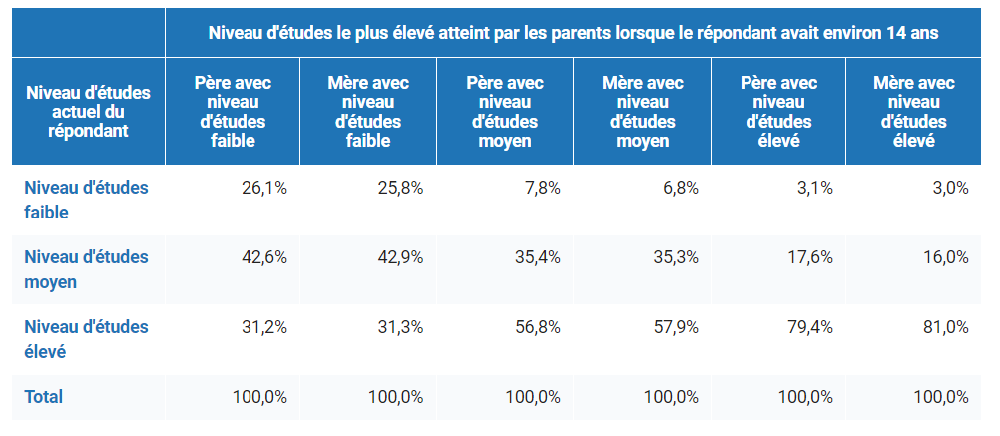

Growing up in a family where parents had a low level of education has a negative impact on living conditions at adult age. The current risk of poverty rate is doubled for a person coming from a household where the parents were less qualified than others.

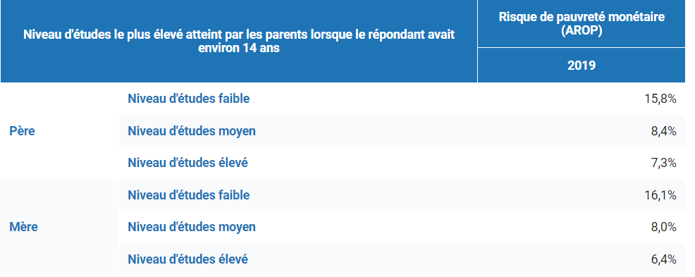

Citizenship

The parents’ citizenship also proves to be a discriminating factor. Among the people whose father or mother did not have a European citizenship, 40.6% and 39.2% respectively are at risk of poverty while the rate is around 7% when the parent is Belgian.

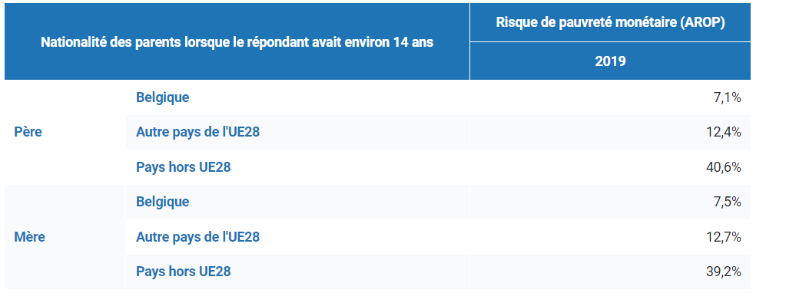

European ranking
In 2022, 24.7% of children (almost 20 million) under the age of 18 in the EU were at risk of poverty or social exclusion. Compared to 2021, this share has risen slightly by 0.3 percentage points (pp).

At national level, in 2022, the highest values were reported in Romania (41.5%), Bulgaria (33.9%) and Spain (32.2%). By contrast, Slovenia (10.3%), Czechia (13.4%) and Denmark (13.8%) recorded the lowest shares. Belgium ranked 17th, with 19.6%.

(¹): Provisional.
Source table: Eurostat

Press questions:
- By email: MI.Press@mi-is.be
- By phone: +32 (0)2 508 86 22 or +32 (0)477 33 04 96

according to figures published by Eurostat.
https://ec.europa.eu/eurostat/statistics-explained/index.php?title=Category:Living_conditions_glossary
The list of coordinators is available on this page (in "Related documents"): https://ec.europa.eu/social/main.jsp?catId=1428&langId=en
https://ec.europa.eu/social/main.jsp?catId=1428&langId=en
https://www.mi-is.be/fr/nouvelles/nouvel-appel-projets-lutte-contre-la-pauvrete-infantile
https://statbel.fgov.be/en/themes/households/poverty-and-living-conditions/risk-poverty-or-social-exclusion
https://statbel.fgov.be/en/news/intergenerational-transmission-poverty-or-how-living-conditions-during-childhood-influence
In the SILC survey, the poverty threshold is set at 60% of the median equivalised income for the whole population. The percentage of people with an equivalised income below this threshold is the total poverty rate. In SILC 2019, the annual median available income at national level is set at 24,608 euros. 60% of it is 14,765 euros or 1,230 euros per month. A total equivalised income below this threshold reflects a risk of poverty.
https://ec.europa.eu/eurostat/web/products-eurostat-news/-/ddn-20230927-1?
https://ec.europa.eu/eurostat/databrowser/view/ILC_PEPS01N__custom_6864718/bookmark/table?lang=en&bookmarkId=bfdfcf6a-fe07-4d9f-830b-0b9125c41bbf

